**MD. ISMAIL HOSSAIN**

**House:10,Road:03, Sector:13, Uttara Dhaka 1230** 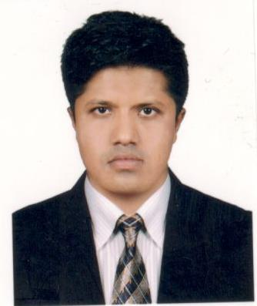

Cell: +8801738115499, E-mail:[ismail91ame@yahoo.com](mailto:ismail91ame@yahoo.com)

**Objective:**

To obtain a challenging position for long term careers goal in the Aviation Maintenance Engineering where able to utilize experience and academic knowledge. Technically experienced in the file of maintenance on the ATR72-500, ERJ-145 & B737NG

**Academic Credential**

**Diploma in Aircraft Maintenance Engineering (B1.1)** Aug2011- Jan 2016

Aeronautical Institute of Bangladesh (AIB)

Approved by Civil Aviation Authority of Bangladesh (CAAB)

**GPA**: 2.73/4.00

**Aircraft Maintenance Engineering (Aerospace)**

Aeronautical Institute of Bangladesh (AIB)

Approved by Civil Aviation Authority of Bangladesh (CAAB)

**Result**- 75%

**Basic Human Performance & Limitation (HPL)**

Aeronautical Institute of Bangladesh (AIB)

Approved by Civil Aviation Authority of Bangladesh (CAAB)

**Result**- 80%

**Basic Airworthiness Legislation (AWL)**

Aeronautical Institute of Bangladesh (AIB)

Approved by Civil Aviation Authority of Bangladesh (CAAB)

**Result**-75%

**Experience**

**Aircraft Mechanic** 08 March, 2017-Present

Regent Airways, Bangladesh

During this Mentioned period, I was involved with line & base maintenance

* Ensure safe Maintenance activities for the safety of the aircraft & personal involved.
* Daily inspection & preflight check of B737NG
* Unscheduled maintenance.
* Schedule maintenance.
* Transit check.

**On The Job Trainee (Maintenance)** 14 Jul, 2016 – 13 Jan, 2017

Novo Air, Bangladesh

* Ensure safe Maintenance activities for the safety of the aircraft & personal involved.
* Learn from the experienced AME & technicians.
* Daily inspection & preflight check of ATR72-500& EMB-145.
* Weekly test of ATR72-500 & EMB-145.
* Unscheduled maintenance.
* Schedule maintenance.

**Apprentice AME** 20 Dec, 2015 -19Mar, 2016

Bangla Int’l Airlines Ltd. Bangladesh.

* Unscheduled maintenance.
* Schedule maintenance.

**Educational Attainment**

**Degree (Pass) B.S.S**

Institute : Tongi Govt. College

University : National University, Bangladesh

Year of Passing : 2014

Grade : 2nd Division

**H.S.C (Secondary School Certificate):**

Institute : Sara Marwari School & College

Board : Rajshahi

Year of Passing : 2010

GPA : 2.80 /5.00

**S.S.C (Secondary School Certificate):**

Institute : Raksha High School.

Board : Rajshahi

Year of Passing : 2007

GPA : 2.63/5.00

**Computer Knowledge:**

Microsoft Office, Internet **browsing**, E-mailing, etc.

**Language**

English Writing, Speaking & Reading

Bangla Writing & Speaking & Reading

**Personal information:**

Father`s Name : Mohmmad Hossain

Mother`s Name : Most. Fatema Begum

Date of Birth : 10th November,1991

Nationality : Bangladeshi

Religion : Islam (Sunni)

Sex : Male

Marital Status : Married

Blood Group : O+(ve)

Passport number : BX0423866

Permanent Address : Vill: Kujipukur, P.O: Raksha, P.S: Lalpur, Dist: Natore

Signature